Chapter 18, Solution 61.

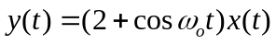

We apply the Fourier Transform

Y(ω) = 2X(ω) + 0.5X(ω+ω_{o}) + 0.5X(ω–ω_{o}).

